Search Data History Program Specifications for ABC Asset Management Fund Fact Sheet Generator
Project ID
Project Name | ABC Asset Management Fund Fact Sheet Generator
Account
Business Unit / Global Account
Project Manager
Document Version Number | 1.0.0
Approved by:

Revision History
Version Number | Release Date | Description of Change/s made | Author  (Name & Role) | Reviewer  (Name & Role) | Approver  (Name & Role)
 | Mmm-DD-YY

Table of Contents
Revision History 2
1. Program Description 4
1.1 Unit Name, Version and Language used 4
1.2 Unit Description 4
2. Input Specifications 4
2.1 Files/Tables 4
2.2 Screen Layouts 4
2.3 Parameters Passed 4
2.4 Validations 4
3. Process Specifications 4
3.1 Program structure chart 4
3.2 Pseudo code 4
4. Output Specification 5
4.1 Files/Tables 5
4.2 Screen Layouts 5
4.3 Report Layouts 5
4.4 Parameters Passed 5
4.5 Output formatting 5
5. Performance 5
6. Security 5
7. Reuse or Third-party component 6

Program Description

Unit Name, Version and Language used

Unit Name: Search Data History
Language used: C#

Unit Description

The program unit will allow the user to search past data history, if it exists.

Input Specifications

Files/Tables

companyInfo
Field Name | Data type | Size | Constraints | Remarks
fundTicker | Varchar | 50 | Primary Key
ISIN | Varchar | 50 | Foreign Key
status | Varchar | 50
companyName | Varchar | 50
sector | Varchar | 50
fixedHoldingRatio | Decimal | 18,0

main
Field Name | Data type | Size | Constraints | Remarks
date | Date |  | Primary Key | Composite
ISIN | Varchar | 50 | Primary Key | Composite
NAV | Decimal | 18,2 | Foreign Key
offer | Decimal | 18,2
benchmarkPrice | Decimal | 18,0

dailyFund
Field Name | Data type | Size | Constraints | Remarks
date | Date |  | Primary Key | Composite
fundTicker | Varchar | 50 | Primary Key | Composite
ISIN | Varchar | 50 | Foreign Key
price | Decimal | 18,2
share | Decimal | 18,0

Screen Layouts

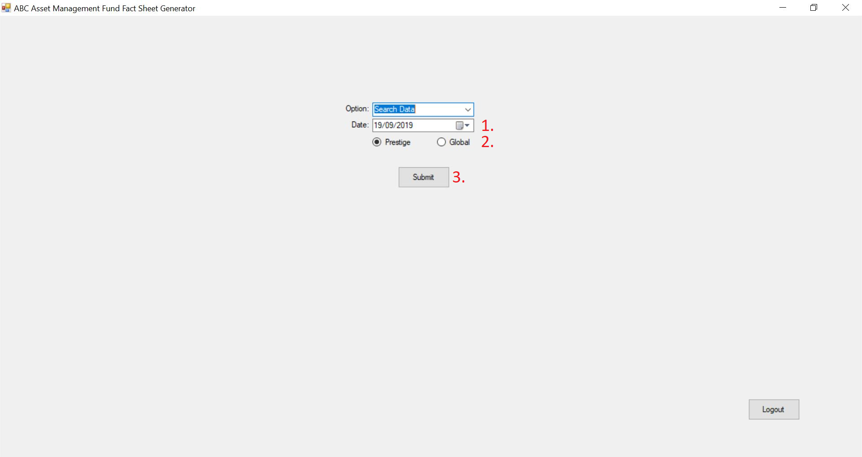

Parameters Passed
1. The specific date of the interested fund fact sheet.
2. The specific region of the interested fund fact sheet.

Validations.
3. Only valid dates are allowed (I.E. dates where there are data)

Process Specifications

Program structure chart

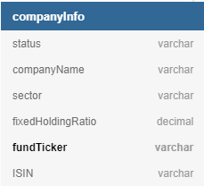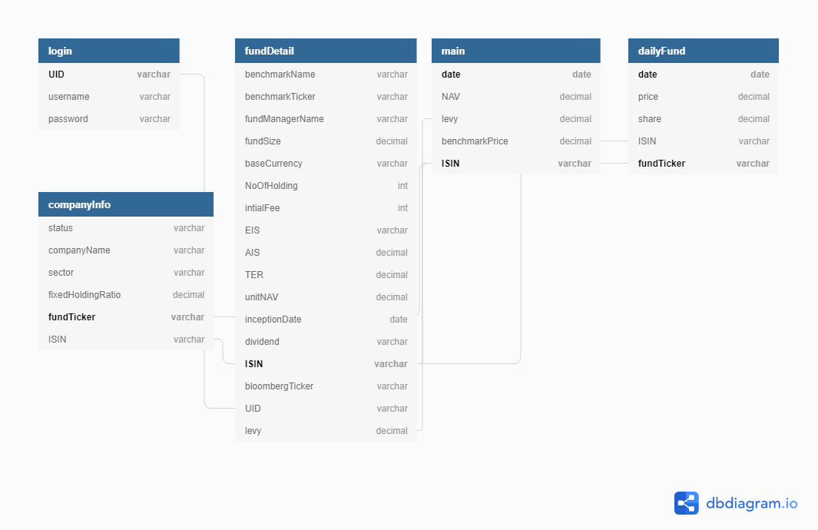

Pseudo code

Display{
Take relevant info from main and dailyFund where date == SelectedDate
Take relevant info from companyInfo where dailyFund.fundTicker == companyInfo.funTicker
Take relevant info for year-to-date, 1 month, 3 month, 6 month, 1 year and since inception.
Display relevant info in the format of a fund fact sheet
}

Output Specification

Files/Tables

Screen Layouts

Report Layouts
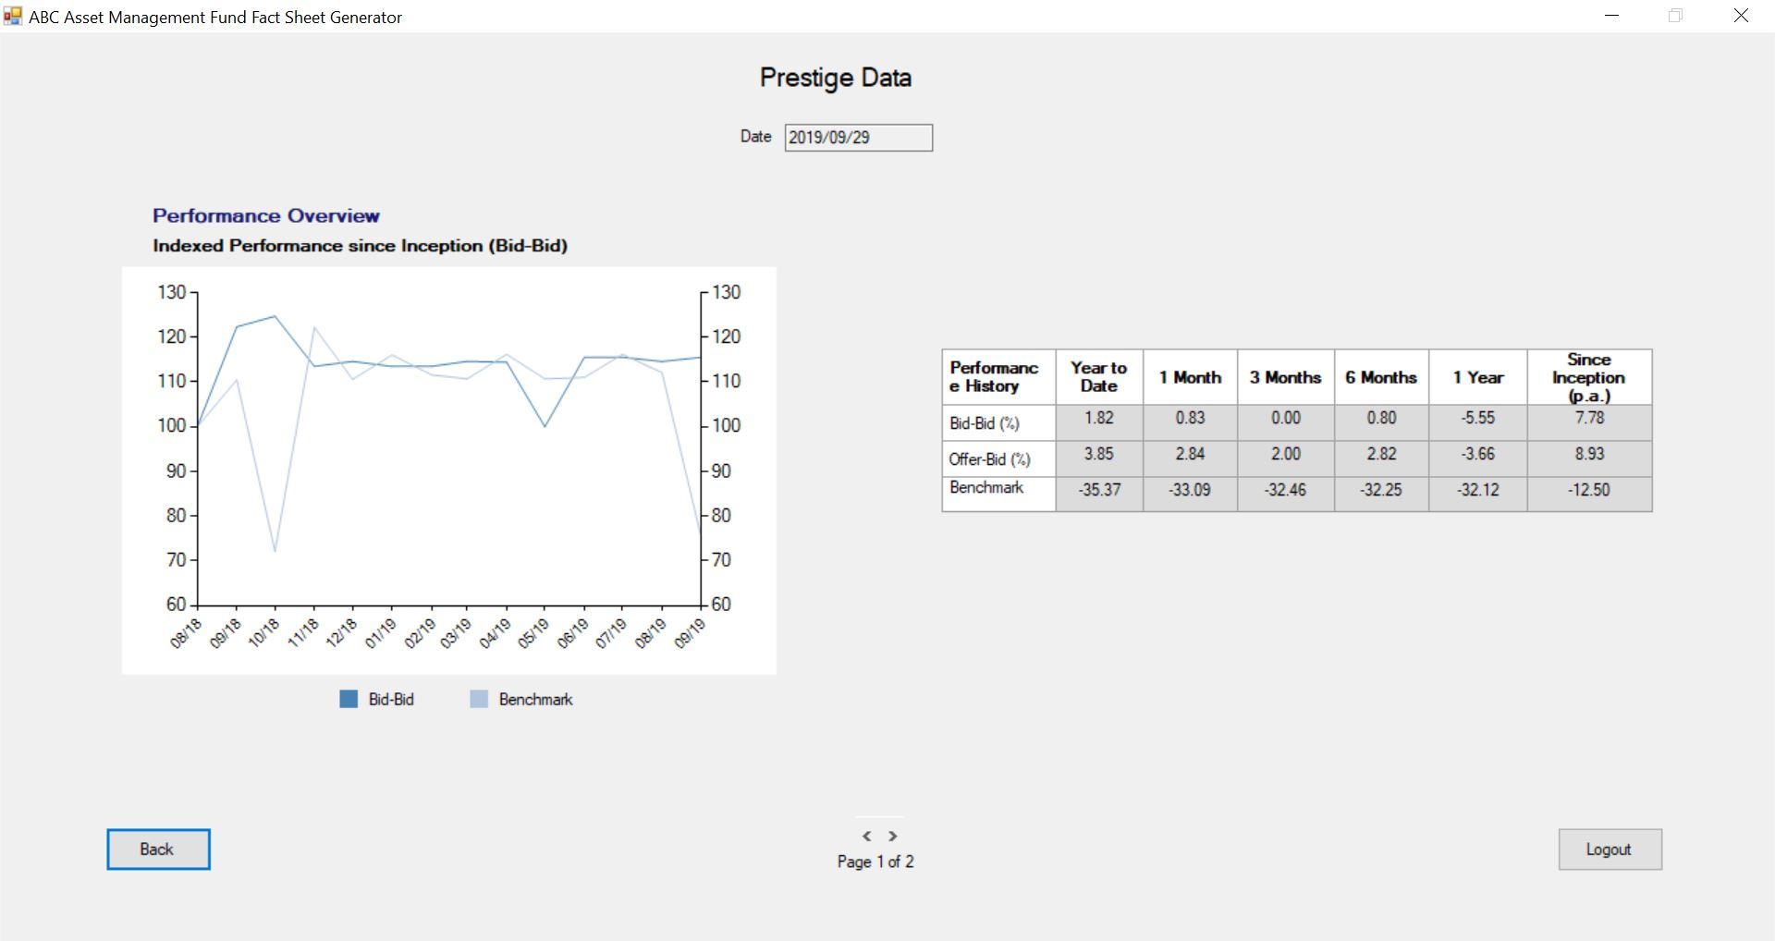

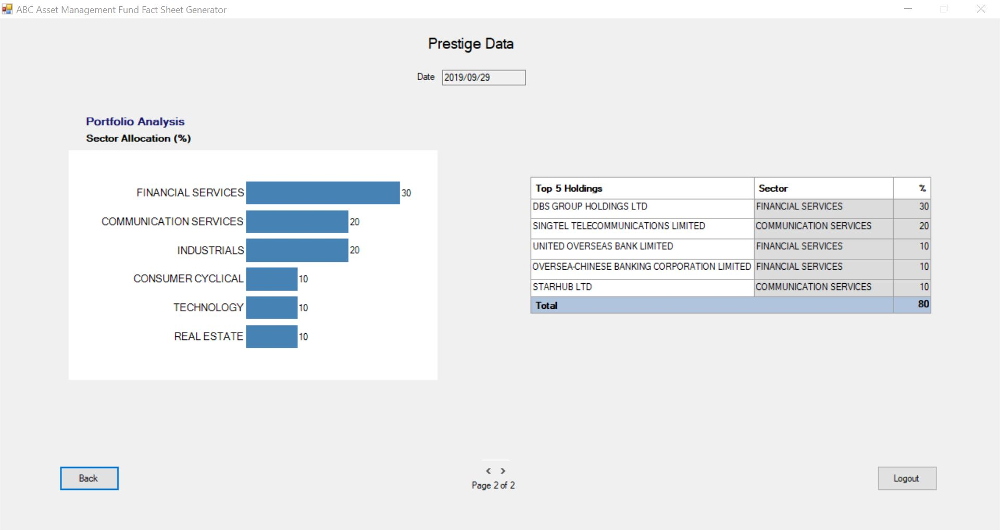

Parameters Passed

Output formatting

Performance

Performance Requirements | Design | Constraints

Security

Application Areas | Identify special transactions and areas requiring Encryption
Application Data | Identify data that requires Encryption
Encryption in Transit/Storage | Identify need for Encryption while data transfer or storage
Encryption Policy | State the policy that governs Encryption

Reuse or Third-party component

External component | Module impacted | Assumptions and Constraints | Source/License

Template Revision History (For EPEX Use Only)
Version Number | Release Date | Description of Change/s made | Author  (Name & Role) | Reviewer  (Name & Role) | Approver  (Name & Role) | QMS Release Version
1.0 | NA | Initial baseline | NA | NA | SEPG | NA
2.0 | Jun-14-11 | Assigned artifact id, version #, release date to the template and modified Information Classification label in the footer | Shreevidhya Srinivasan, PM | Radhika Seenivasakan, SEPG | Rajesh Sreekumar, SEPG | 4.2
2.1 | Nov-30-18 | Modified SEPG references to EPEX as a part of Re-Org | Prakash Palaniswamy, EPEX | Pradeep Kumar Pullathil, HEAD, EPEX | Pradeep Kumar Pullathil, HEAD, EPEX | 7.5

